**SmartInternz Long Term Virtual Internship**

**An Internship Report submitted in partial fulfilment of the requirements for the award of degree of**

**BACHELOR OF TECHNOLOGY**

**IN**

**ELECTRICAL AND ELECTRONICS ENGINEERING**

**TEAM ID: LTVIP2023TMIDO5996**

**Submitted by:**

**MOHAMMED KAZER 216E5A0210**

**CHEPANA DURGA PRASAD 206E1A0203**

**GUNDU SEKHAR 216E5A0206**



**DEPARTMENT Of ELECTRICAL AND ELECTRONICS ENGINEERING**

**GONNA INSTITUTE OF INFORMATION TECHNOLOGY AND SCIENCES**

**Approved by AICTE – New Delhi, Affiliated in JNTU-GV Vijayanagaram, SBTET -Vijayawada**

**Ward No-85, Gonnavanipalem, Aganampudi, Vishakapatanam-53, Andhra Pradesh**

**SMARTINTERNZ VIRTUAL INTERNSHIP**

**AI ENABLED CAR PARKING USING OPEN-CV**

* **Introduction:**

With the rapid advancements in artificial intelligence and computer vision technologies, the automotive industry has witnessed a paradigm shift in car parking solutions. AI-enabled car parking systems have emerged as an efficient and smart way to address the challenges of limited parking spaces in urban areas. One such technology that has gained significant attention is the integration of OpenCV with AI algorithms to create robust and reliable car parking systems.

OpenCV (Open-Source Computer Vision Library) is an open-source library that provides a wide range of tools and functions for image processing and computer vision tasks. It has become a popular choice for developers and researchers to develop applications in various fields, including robotics, automation, and surveillance.

The AI-enabled car parking system utilizing OpenCV involves employing cameras or sensors to monitor the parking area, which captures real-time images or video streams. OpenCV processes these images to detect and track vehicles, analyse their positions, and determine parking availability. This information is then relayed to the drivers through user-friendly interfaces, such as mobile apps or digital displays, helping them find the nearest available parking spot quickly and efficiently.

As urban centres continue to grapple with increasing vehicular traffic and limited parking space, the demand for smarter and more efficient parking solutions becomes paramount. In response to these challenges, the integration of artificial intelligence and computer vision technologies with OpenCV has revolutionized the way we approach car parking systems. This innovative approach offers an array of benefits, from optimizing parking space usage to reducing congestion and improving the overall driving experience.

AI-enabled car parking systems have emerged as a game-changer in the automotive industry, providing real-time parking availability information to drivers. By harnessing the power of OpenCV's cutting-edge image processing capabilities, cameras or sensors placed strategically in parking lots can detect and track vehicles, enabling the system to analyse parking space occupancy with unprecedented accuracy and speed.

In this article, we explore the key components of AI-enabled car parking using OpenCV, highlighting the seamless integration of computer vision algorithms and AI intelligence. We delve into the advantages of this revolutionary system, ranging from efficient parking management to increased revenue generation and enhanced security measures. As the demand for smarter urban mobility solutions grows, understanding the potential of AI-enabled car parking using OpenCV becomes essential in transforming our cities into more efficient and driver-friendly spaces.

**Key Components of AI-Enabled Car Parking Using OpenCV:**

1. Camera or Sensor Setup: High-resolution cameras or sensors are strategically placed in the parking area to capture real-time images or video streams of the parking spaces.
2. Image Processing with OpenCV: OpenCV's powerful image processing capabilities come into play at this stage. It involves tasks like image filtering, edge detection, and object detection, enabling the system to recognize and identify vehicles in the parking lot.
3. Vehicle Detection and Tracking: The AI algorithms implemented in conjunction with OpenCV can accurately detect and track vehicles' positions and movements within the parking area. This information is crucial for analysing parking space availability.
4. Parking Space Analysis: By analysing the detected vehicles' positions and sizes, the system can determine whether a parking space is vacant or occupied. This real-time analysis helps create a dynamic parking map, which can be accessed by drivers in their vehicles.
5. User Interface: The AI-enabled car parking system provides a user-friendly interface for drivers to access parking information conveniently. This can be through a mobile app, a web application, or digital displays within the parking lot.
6. Advanced Camera or Sensor Setup: To ensure efficiency, the AI-enabled car parking system relies on high-quality cameras or advanced sensors strategically positioned throughout the parking area. These sensors should have a wide field of view and high-resolution capabilities to capture detailed images or video streams.
7. Real-time Image Processing with OpenCV: OpenCV's real-time image processing capabilities are at the core of the system's efficiency. It performs tasks like object detection, image filtering, and edge detection swiftly and accurately. Real-time processing ensures that parking space occupancy is continuously updated, providing drivers with the latest parking information.
8. Fast Vehicle Detection and Tracking: The AI algorithms integrated with OpenCV are optimized for quick and precise vehicle detection and tracking. By efficiently identifying vehicles as they enter or leave the parking area, the system can maintain an up-to-date parking occupancy map.
9. Parallel Processing and Hardware Acceleration: To further enhance efficiency, the system can leverage parallel processing and hardware acceleration techniques. These optimizations allow for faster execution of image processing tasks, enabling real-time analysis of parking spaces even in large parking lots with numerous vehicles.
10. Cloud Connectivity and Distributed Architecture: For scalability and efficiency in managing parking data, the system can be designed with cloud connectivity and a distributed architecture. This allows multiple parking lots to share information and makes it easier to scale the system as the number of parking areas increases.
11. Predictive Analytics: To anticipate parking demand and optimize space allocation, predictive analytics can be integrated into the system. By analysing historical data, seasonal patterns, and events, the AI-enabled car parking system can make intelligent predictions, ensuring a smoother parking experience for drivers.
12. User-friendly Mobile Apps and Interfaces: An efficient car parking system is not only about accurate detection but also about delivering information to drivers seamlessly. User-friendly mobile apps and interfaces can provide real-time parking availability, guiding drivers to the nearest vacant spots, reducing the time spent searching for parking.
13. Automated Payment and Ticketing: To minimize human intervention and streamline parking operations, the system can incorporate automated payment and ticketing mechanisms. This can include cashless payment options through mobile apps or RFID-based ticketing systems, facilitating a seamless entry and exit process.
14. Integration with Navigation Systems: By integrating with popular navigation systems, the AI-enabled car parking system can provide drivers with parking information along their routes. This integration ensures that drivers have access to parking options in advance, avoiding unnecessary detours and congestion around popular destinations.

**Advantages of AI-Enabled Car Parking Using OpenCV:**

1. Real-time Parking Space Updates: OpenCV's fast image processing capabilities, combined with AI algorithms, enable the system to provide real-time updates on parking space availability. This efficiency ensures that drivers receive the latest information, reducing the time spent searching for a vacant parking spot.
2. Optimal Space Utilization: By accurately detecting and tracking vehicles, the system can optimize parking space utilization. It prevents unnecessary wastage of space and ensures that every available spot is efficiently allocated, maximizing the number of vehicles that can park in the area.
3. Reduced Traffic Congestion: The efficiency of AI-enabled car parking using OpenCV leads to quicker parking, resulting in reduced traffic congestion around parking lots and nearby streets. This helps improve overall traffic flow and reduces the environmental impact of idling vehicles.
4. Enhanced User Experience: The seamless and user-friendly interfaces, such as mobile apps and digital displays, enhance the overall user experience for drivers. They can easily find available parking spaces, pay for parking digitally, and navigate to their destinations more efficiently.
5. Cost Savings: Efficient parking management can lead to cost savings for both drivers and parking lot operators. Drivers spend less time searching for parking, reducing fuel consumption and associated costs. Parking lot operators can optimize revenue by effectively utilizing parking spaces and potentially introducing dynamic pricing models.
6. Scalability and Integration: AI-enabled car parking systems using OpenCV can be easily scaled and integrated with existing infrastructure. They can cover multiple parking lots, cities, or even regions, creating a comprehensive network of smart parking solutions.
7. Improved Security: With continuous monitoring and real-time analysis, the system enhances security in parking areas. Suspicious or unauthorized vehicle activities can be detected promptly, alerting authorities to potential security threats.
8. Sustainability: By reducing the time spent looking for parking and minimizing traffic congestion, AI-enabled car parking helps lower greenhouse gas emissions and contributes to a more sustainable urban environment.
9. Predictive Analytics for Planning: The integration of predictive analytics allows for better planning of parking space allocation based on historical data and trends. This foresight helps adapt to changing parking demands and events, providing a more efficient parking experience for users.
10. Seamless Integration with Navigation: Integrating parking availability information with navigation systems helps drivers plan their routes more effectively, reducing detours and congestion. This integration streamlines the entire journey and enhances overall mobility.

**Conclusion:**

AI-enabled car parking systems leveraging OpenCV have revolutionized the way we approach parking space management. By harnessing the power of computer vision and AI algorithms, these systems bring efficiency, convenience, and security to both drivers and parking lot operators. As technology continues to advance, we can expect even more sophisticated and intelligent parking solutions to make urban mobility smoother and more sustainable.

**OUTPUT PHOTO’S**

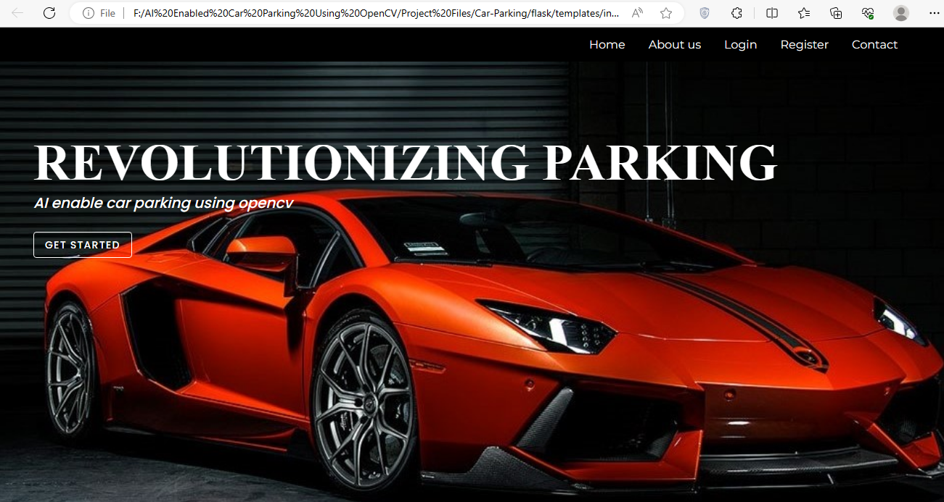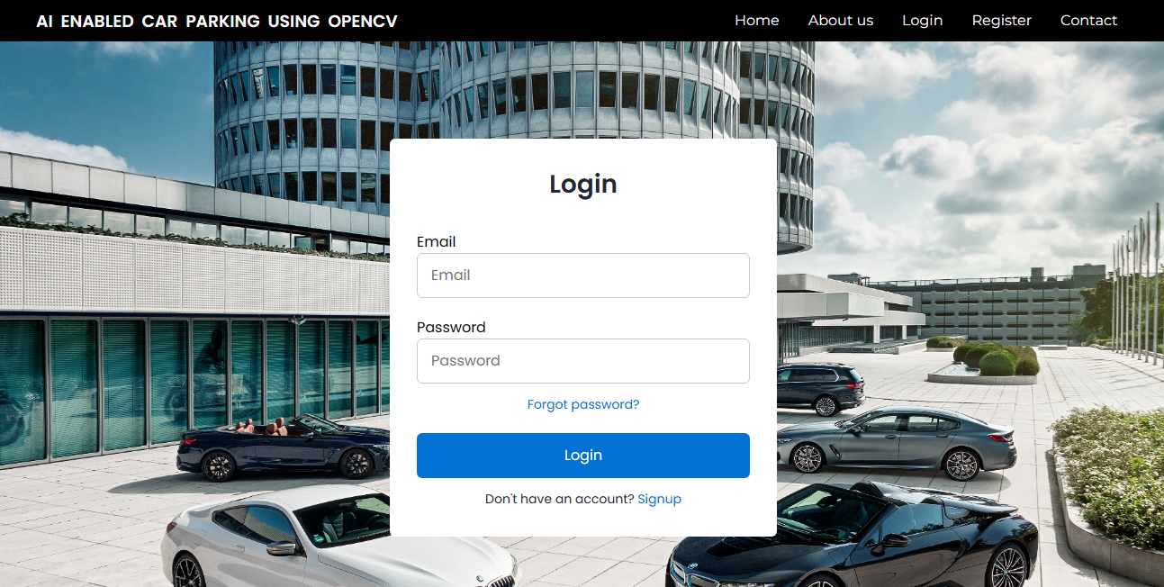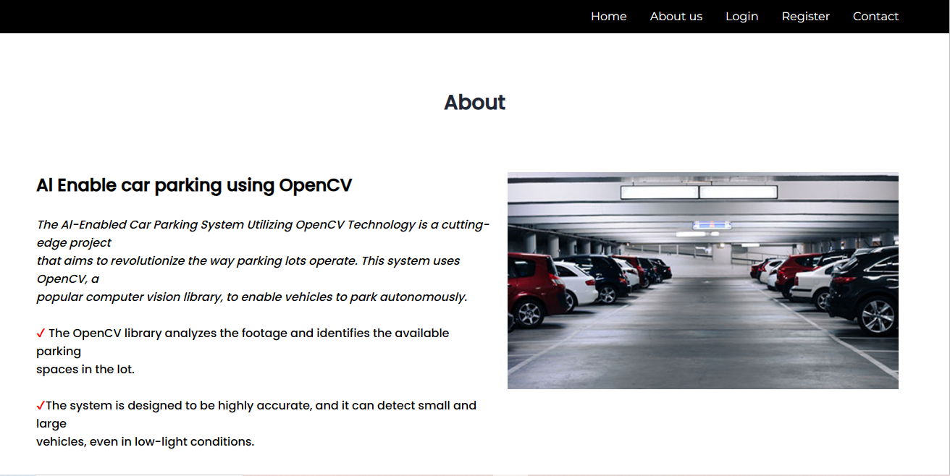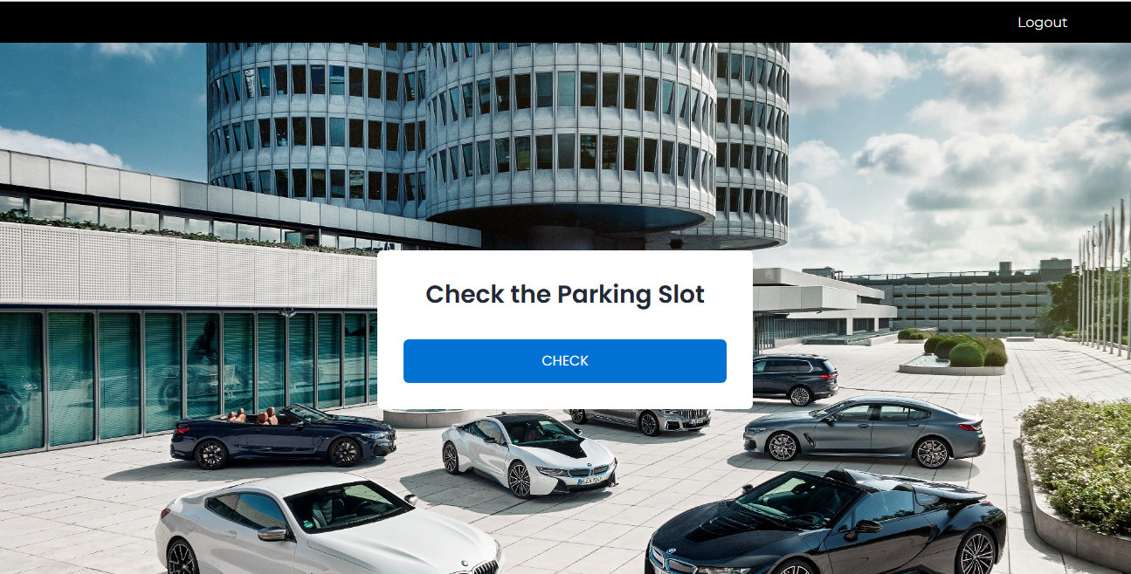

**THANK YOU**